**1050 Programming Logic**

Lab 6 (20 points total)

Name: ____Dhruvil Patel_____

***Instructions:*** *Complete the following exercises. Paste your code into this document and submit this Word document to Blackboard when complete.*

1. Fill in the blanks in the following statement (2 points):

A one-dimensional array p contains four elements. The array access expressions to access each of the elements in p are _p[0]_, _p[1]_, _p[2]_ and _p[3]___.

1. Create a 12-element array called months. Set each element to the name of each month.

For example months[0] = “January”. Use a for loop to display the number and name of each month. (4 points)

Code:

int[] array = new int[12];

Console.WriteLine("{0}{1}{2}", "Index", "\t", "Month");

string[] month = new string[12];

month[0] = "January";

month[1] = "February";

month[2] = "March";

month[3] = "April";

month[4] = "May";

month[5] = "June";

month[6] = "July";

month[7] = "August";

month[8] = "September";

month[9] = "October";

month[10] = "November";

month[11] = "December";

{

for (int counter = 0; counter < array.Length; counter++)

Console.WriteLine("{0}{1}{2}", counter,"\t", month [counter]);

}

Execution:

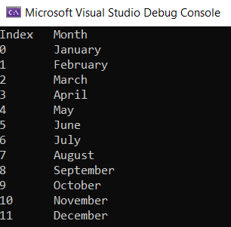

1. Create a 4-element array to store the names of 4 seasons. Use a foreach loop to display the name of each season. (4 points)

Code:

String[]seasons= { "Spring", "Summer", "Fall", "Winter" };

foreach (string season in seasons)

{

Console.WriteLine(season);

}

Execution:

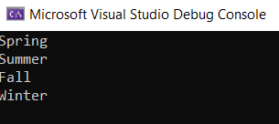

1. Create an array of integers with 1000 elements. Fill the array with random numbers. Use a foreach loop to print all integers in the array (4 points).

Random random = new Random();  
int randomNumber

randomNumber = random.Next(0, 100); // place this line in the loop

Code:

int[] randomNumber = new int[1000];

Random random = new Random();

for (int i = 0; i < randomNumber.Length; i++)

{

randomNumber[i] = random.Next(0, 100);

}

foreach (int i in randomNumber)

{

Console.WriteLine(i.ToString());

}

Execution:

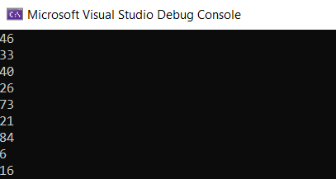

1. Paste the following code into the main() method. Modify the code; so that it works (You’ll have to make 2 small modifications). It should output the value of each string in the array called names (2 points).

string[] names = { "Al Dente", "Anna Graham", "Earle Bird", "Ginger Rayle", "Iona Ford" };

int i = 0;

while (i < names.Length)

{

Console.WriteLine(names[0]);

}

Modified Code:

string[] names = { "Al Dente", "Anna Graham", "Earle Bird", "Ginger Rayle", "Iona Ford" };

int i = 0;

while (i < names.Length)

{

Console.WriteLine(names[i]);

i++;

}

Execution:

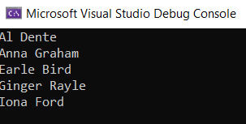

1. Modify the code from problem 5, so that it outputs a number and then a person’s name using the following output statement (1 point).

Console.WriteLine("{0,2}. {1}", i, names[i]);

Code:

string[] names = { "Al Dente", "Anna Graham", "Earle Bird", "Ginger Rayle", "Iona Ford" };

int i = 0;

while (i < names.Length)

{

Console.WriteLine("{0,2}. {1}", i, names[i]);

i++;

}

Execution:

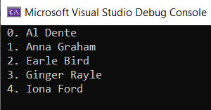

1. Modify the code from problem 6, so that it uses a *foreach loop* as opposed to a while loop. The output should appear exactly the same as it did after step 2 (3 points).

Code:

string[] names = { "Al Dente", "Anna Graham", "Earle Bird", "Ginger Rayle", "Iona Ford" };

int i = 0;

foreach(string name in names)

{

Console.WriteLine("{0,2}. {1}", i, names[i]);

i++;

}

Execution:

